**Australian Tonalism**

Tonalism is an often under-appreciated aspect of Australian painting, which developed from the mid 1910s to the 1950s. A technique pioneered by Max Meldrum (1875-1955) it is different to the use of tone developed by artists such as Leonard da Vinci (1452-1519) and Johannes Vermeer (1632-1675). Traditionally, European artists worked from dark to light, building up the painted surface to model form and create realistic effects as part of the will to produce illusionistic forms and space on a two-dimensional painted surface. This process is based on closely observed preliminary sketches. In Australia, the technique developed by Meldrum involved the blocking in of tonal impressions with no under-drawing or outlines. Students would first place their easel very close to their subject then were encouraged to step at least twenty feet or six meters back and observe the subject by half closing their eyes (or sometimes using sunglasses). As one of Meldrum’s students, artist A.M.E. Bale said, they had to seek ‘the setting down of optical impressions in their due order of precedence – the strongest contrast, the darkest dark, the lightest light – whatever “pulls the eye” and claims the attention first.’ The result was often soft focus effects that created a moody or misty atmosphere.

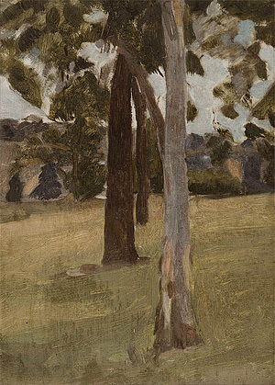

Max Meldrum, The Three Trees, c.1917. (Max Meldrum, *The Three Trees*, c.1917

Private Collection – therefore, best to access via Tracey Lock-Weir, curator at Art Gallery of South Australia. Copyright is owned by the estate of the artist.

- an alternative to this could be *Shadows, landscape with trees*c.1925 from the National Gallery of Australia collection, though the 1917 work would be better)

Charged with using only five tones, Meldrum’s intention was to construct ‘spatial depth’: a spontaneously produced perception of nature, but one needing time for the viewer to take in. Meldrum considered his tonal method a ‘pure science’, producing an exact effect of nature, and believed that anyone could learn to paint using this approach. Meldrum established his own school in Melbourne in 1917 and his students included Clarice Beckett, Hayward Veal, Percy Leason, Colin Colahan. His influence also extended to artists such as William Frater, Arnold Shore, Roy de Maistre, Roland Wakelin and Lloyd Rees. His own use of the technique can be seen in *The Three Trees*, c. 1917, though it must be said that his achievement was exceeded by many of his own students, such as Clarice Beckett and Colin Colahan. Even Wakelin and de Maistre, for instance, moved away from their own explorations with colour theory to experiment with Meldrum’s tonal method.

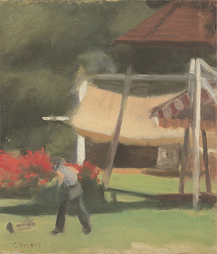

Clarice Beckett, Hawthorn Tea Gardens, c. 1936

In 1919, Meldrum’s students held an exhibition at the Melbourne Athenaeum Gallery, which controversially divided the opinions of the art community. By the early 1920s his followers became known as ‘Meldrumites’. Meldrum himself was rigorous in advancing his method through lectures (for example, *The Invariable Truths of Depictive Art,* 1917) and books (*Max Meldrum: His art and his views*, 1917, and *The Science of Appearances*, 1950). In subsequent years Meldrum was largely dismissed as a conservative anti-modernist. However some have argued that, while Meldrum himself remained fairly conservative, his method did open up a generation of Australian artists to the potential of modernism. Certainly he was a rare creature in Australian art having developed and taught his own unique theory of painting.

**References and Further Reading:**

Colahan, Colin, ed. (1919) *Max Meldrum: His Art and His Views*, Melbourne: McCubbin. (Includes his 1917 lecture ‘The Invariable Truths of Depictive Art’)

Lock-Weir, Tracey, (2008) *Misty Moderns: Australian Tonalists 1915-1950,* exhibition catalogue, Art Gallery of South Australia.

Meldrum, Max. (2008, 1950) *Meldrum: The Science of Appearances*, Ames, Kenyon R (re-arranged and edited), Frankston South: Cinemascope Productions.

Perry , Peter & Perry, John. (1996) *Max Meldrum and associates: their art, lives and influences*, Victoria: Castlemaine Art Gallery and Historical Museum.